***User Guide***

This application allows you to use create and manage stock portfolios, hereby referenced as folios. The application allows for multiple folios at a time in the form of tabs. This can be used by one person to split up their stocks into groups or be an entirely separate users folio. An example is shown in Figure 1.



Figure 1 Tabs for users

Managing multiple folios is as simple as clicking on the tab of the folio you want to work with.

In order to get to that point, we first need to create a folio. This is done by using the file menu shown in Figure 2. This menu also gives you the option to save and load our own custom ‘.folio’ files. This will give a popup asking you to give the name of your folio, showing in Figure 3

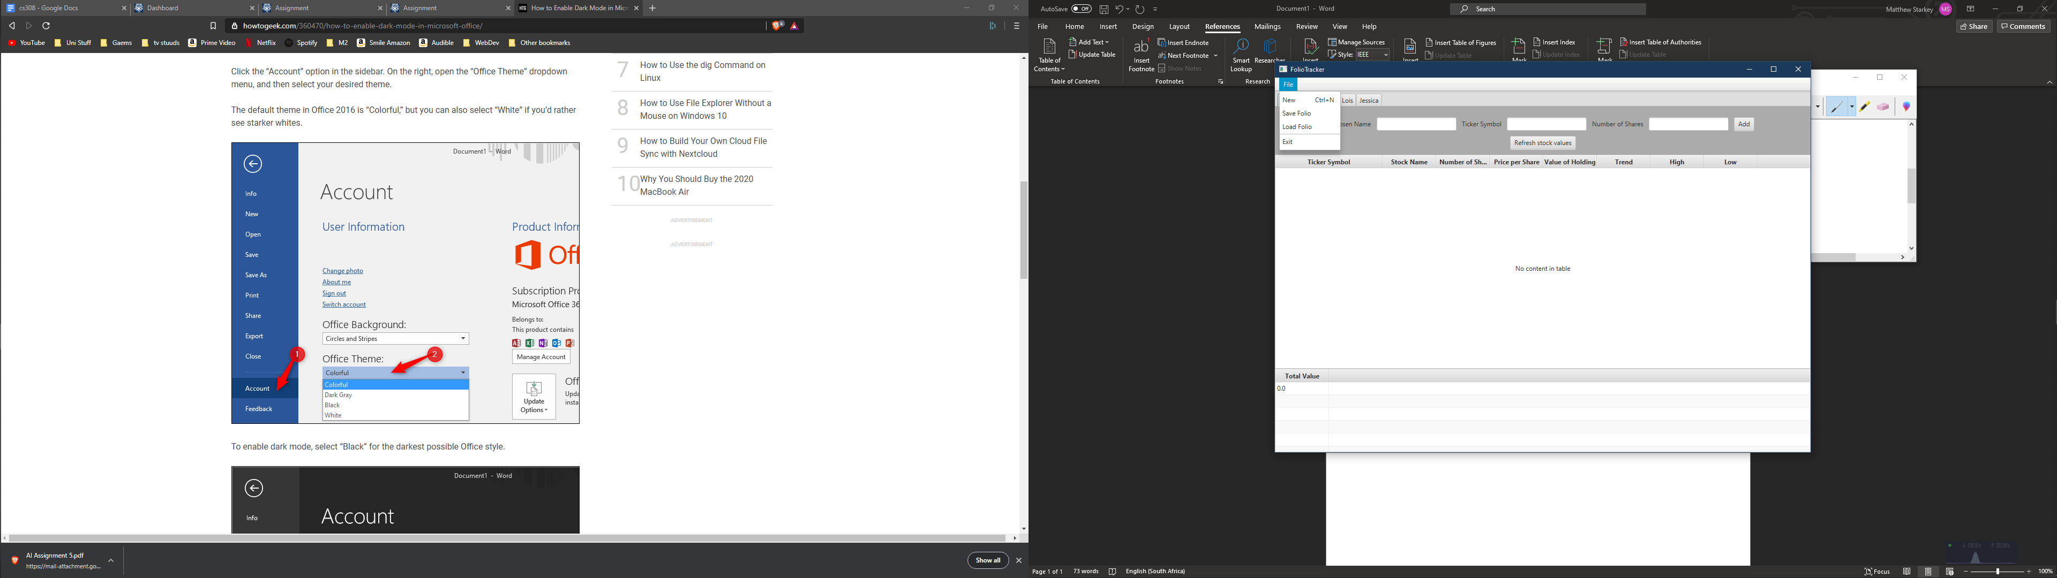

Figure 2 Create, Load and Save folios

Click new on Figure 2 will create a popup asking for a folio name. This will also be the name of the tab. This popup is shown in Figure 3. When loading a folio, you will need to guide the explorer to the location of your ‘.folio’ file. Once the file has been found and read successfully, it will automatically open in a new tab. If it cannot be read successfully, you will be notified via a popup.

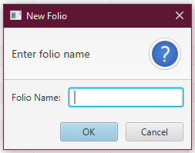

Figure 3 Creating a folio

Within a tab you will see 3 main sections, highlighted in Figure 4.

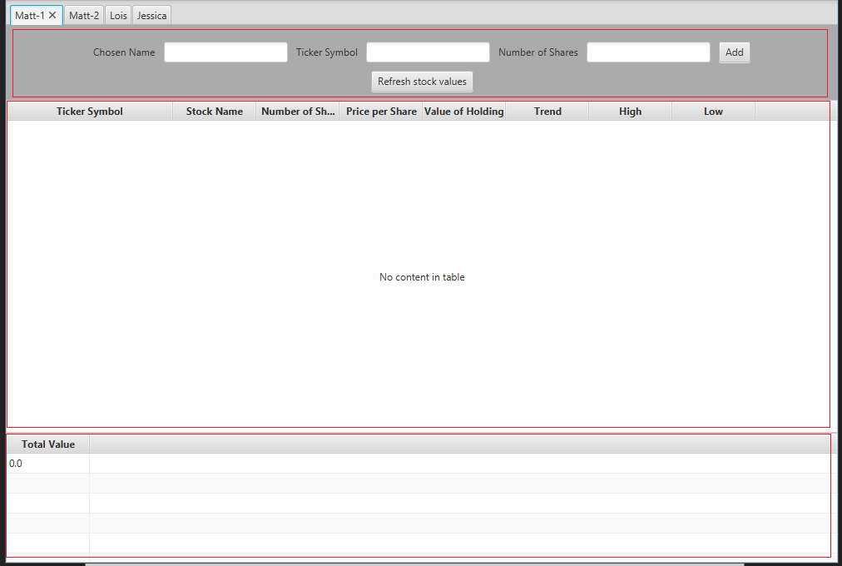

Figure 4 Full tab view with highlighted sections

The top section is where you add a new stock. You give it a recognisable name, a ticker symbol and how many shares you want to initially buy. Any invalid data will result in nothing being added to the table and a popup asking you to try again. Trying to add the same stock twice will warn you about what you are doing and prompt you to double click the stock you wish to interact with. There is also the option to initiate a refresh. This shouldn’t be necessary for most use cases as each tab refreshes once a minute automatically. This is done on a separate thread to help with performance.

The middle section is where your current folio’s stock will show.

The last section shows you the total value of this folio.

Each refresh, manual or automatic, will update all values in the middle and bottom sections.

Once your stocks are added your middle section will look like Figure 5.

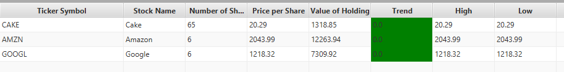

Figure 5 Initial added stocks

The key data is shown in the table. The notable columns are the trend, which tells you if the current price of the stock is higher or lower than when you initially bought it. This corresponds to a change in the background colour of that cell for maximum visibility, shown in Figure 6.

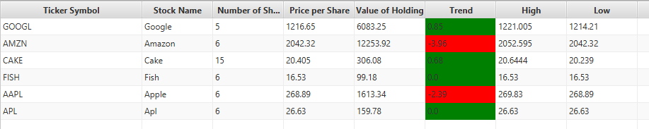

Figure 6 Changing background colours

The high and low columns keep track of the max and min price per share that the stock has hit since you added it to your folio. Clicking the column headings will allow you to sort by each category. Double clicking a stock will allow you to view additional details as well giving the options to buy and sell. This is shown in Figure 7.

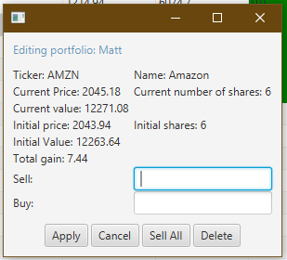

Figure 7 Editing stock popup

Here we can see extra information about out stock as well as buy and sell shares. You will not be able to sell more shares than you have and will get a popup warning you about your action if you try. The popup in Figure 7 also gives you the ability to delete your stock. This will not be allowed if you still have shares left in this stock. If you try there will be yet another popup warning you about your actions. Deleting your stock will remove it from the table of stocks, therefore you will lose any tracking data you have on that stock up until this point.

Finally, if you want to check the total value of your current folio, just look at the bottom left, Figure 8, this will give the an up to date total value.

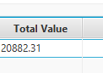

Figure 8 Total value of folio

Once you are finished playing the stock markets for the day, you may try to close your tabs. On each tab you attempt to exit, you will be prompted to save your folio, shown in Figure 8.

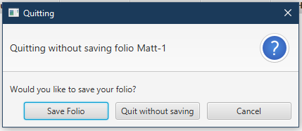

Figure 9 Quitting tab

If attempting to exit the entire application without closing all your tabs, Figure 9 will show, preventing you from quitting until you have dealt with all open tabs. This is to prevent you from accidently closing your folios with saving.

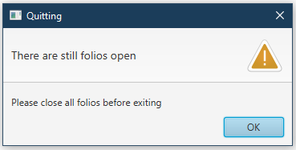

Figure 10 Quitting whole program

Once all tabs have been dealt with, you will be able to close the program.